EXERCISE-01
Query -01:
This gives a unique rank within each category.

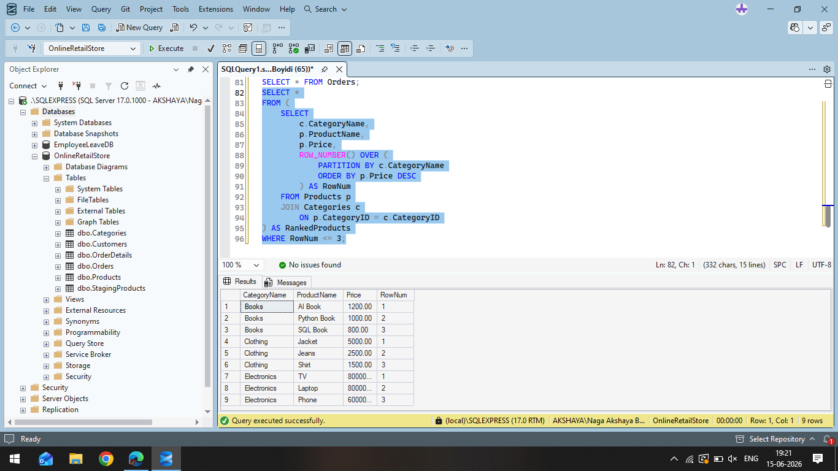

Query 2:
Assigns ranks to products, but skips rank numbers when there are ties.
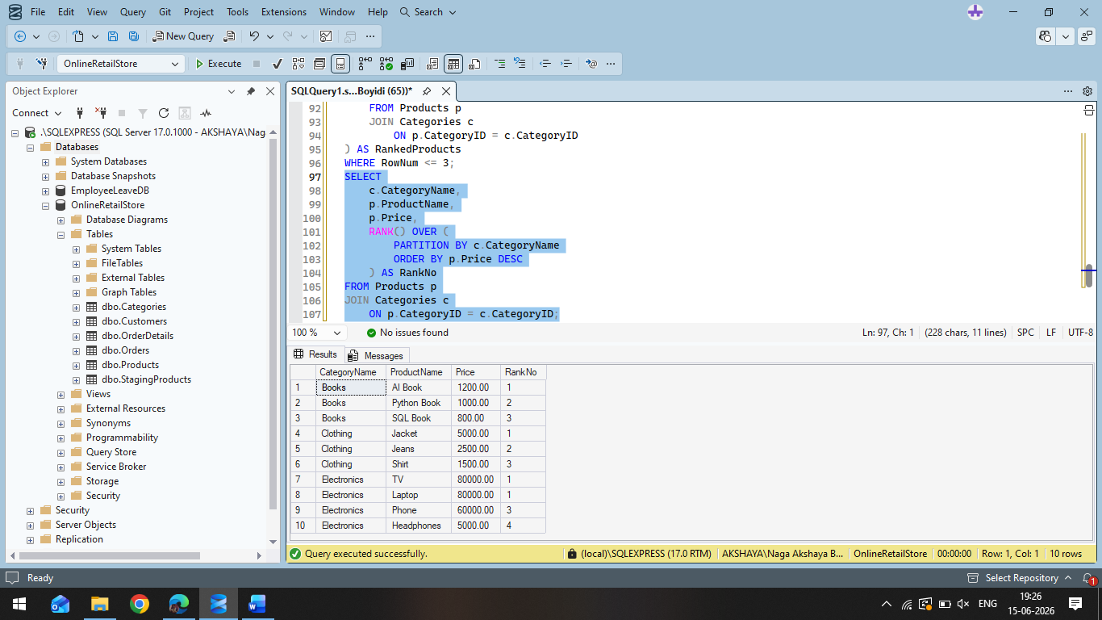
Query-03:
Assigns ranks to products without skipping rank numbers after ties.

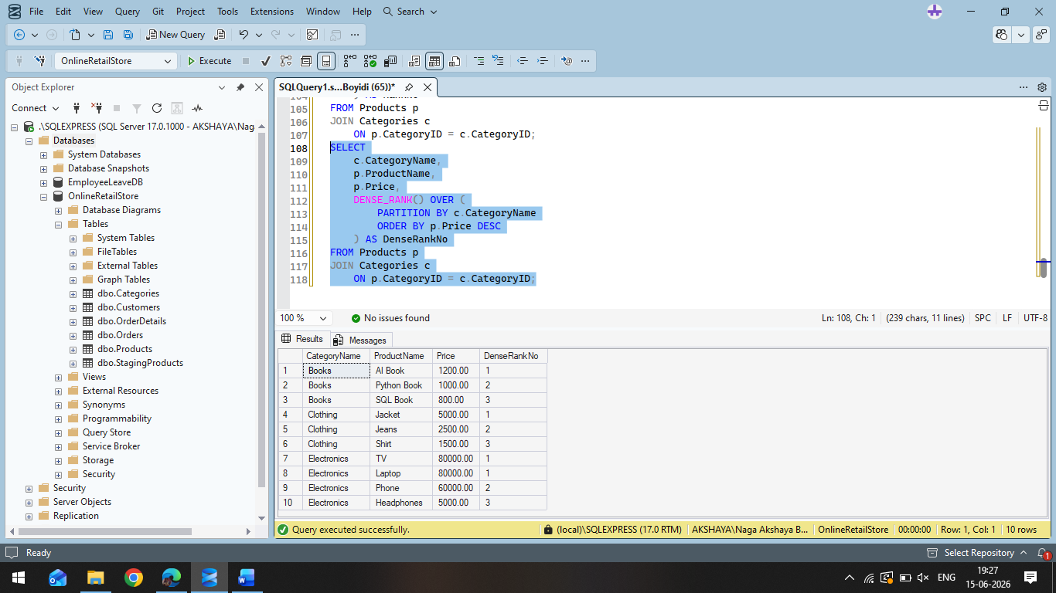

EXERCISE-02
Query-01:
Produces summaries for selected group combinations in a single query.
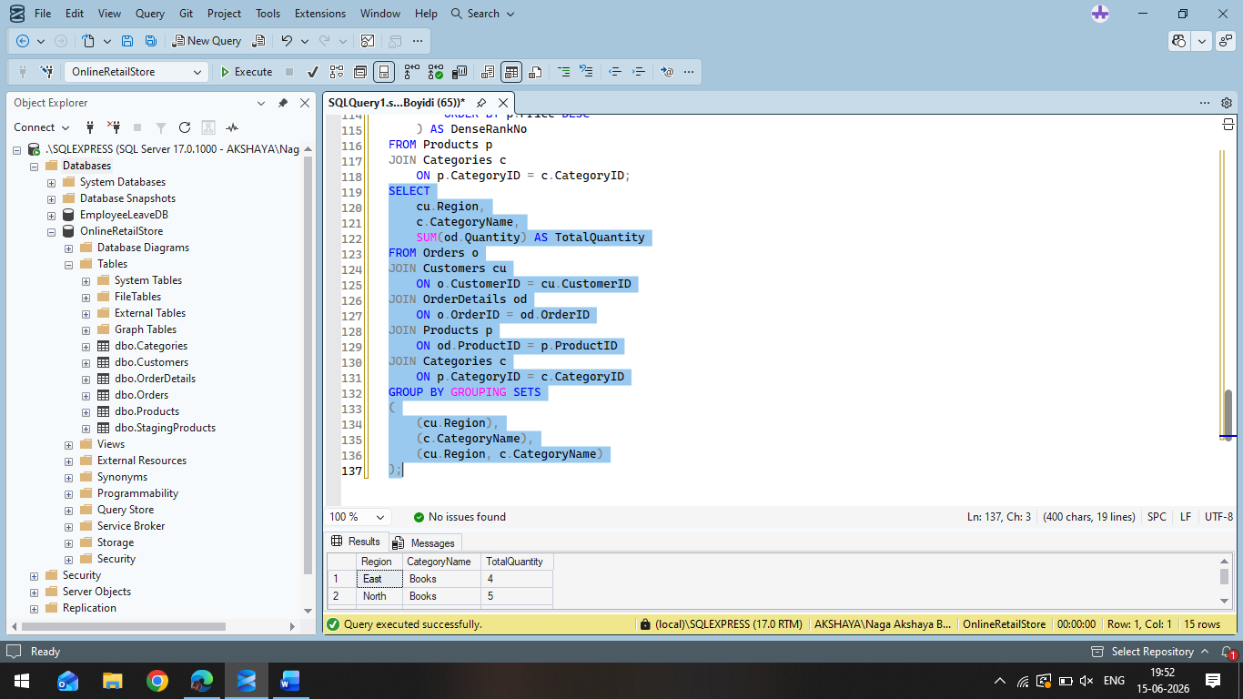
Output:

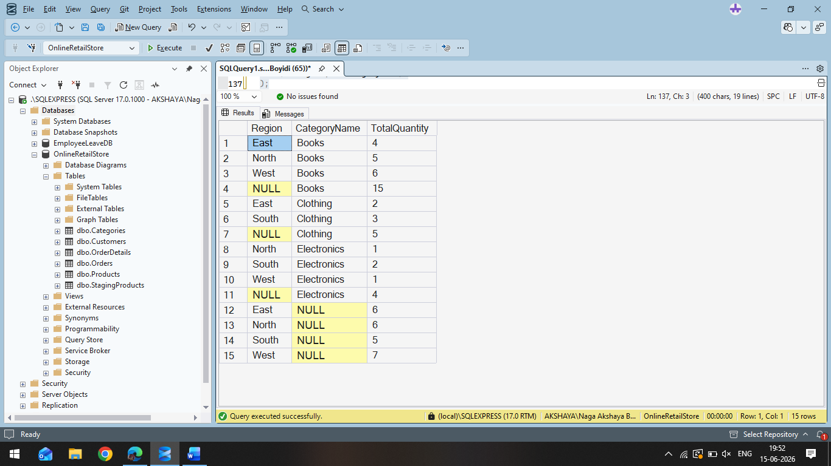

Query-02:
Generates subtotals and a grand total hierarchically.
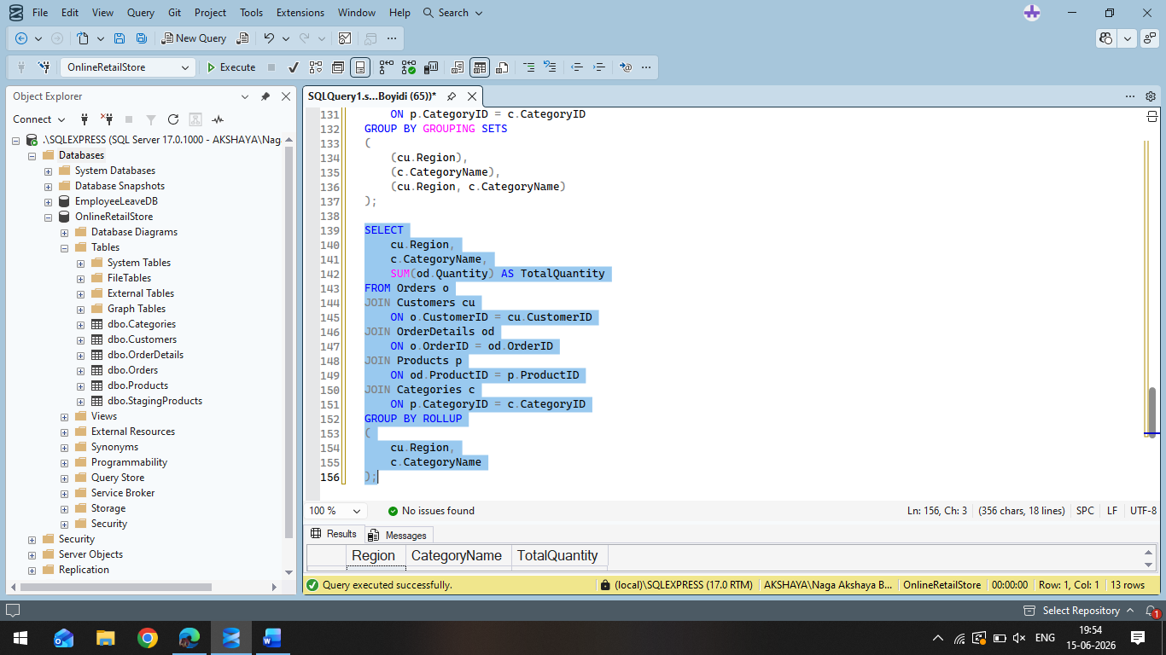

Output:
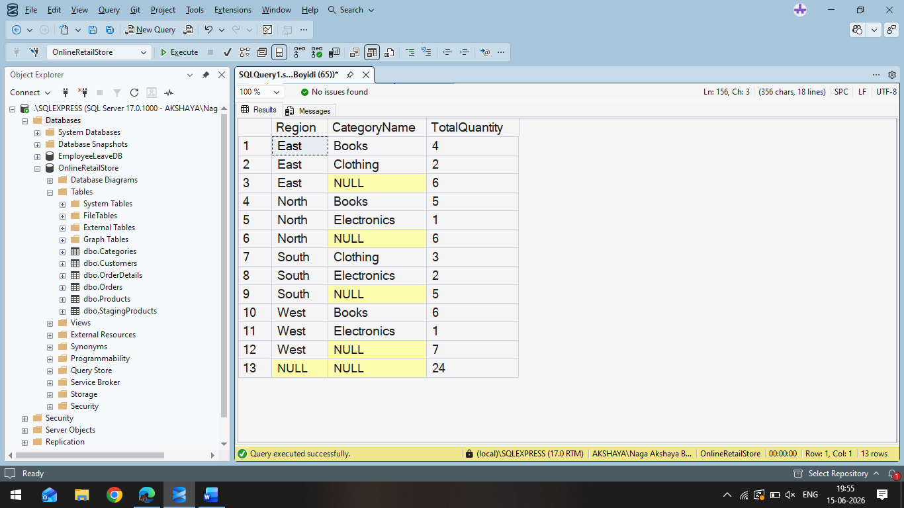

Query-03:
Generates totals for all possible combinations of grouping columns.
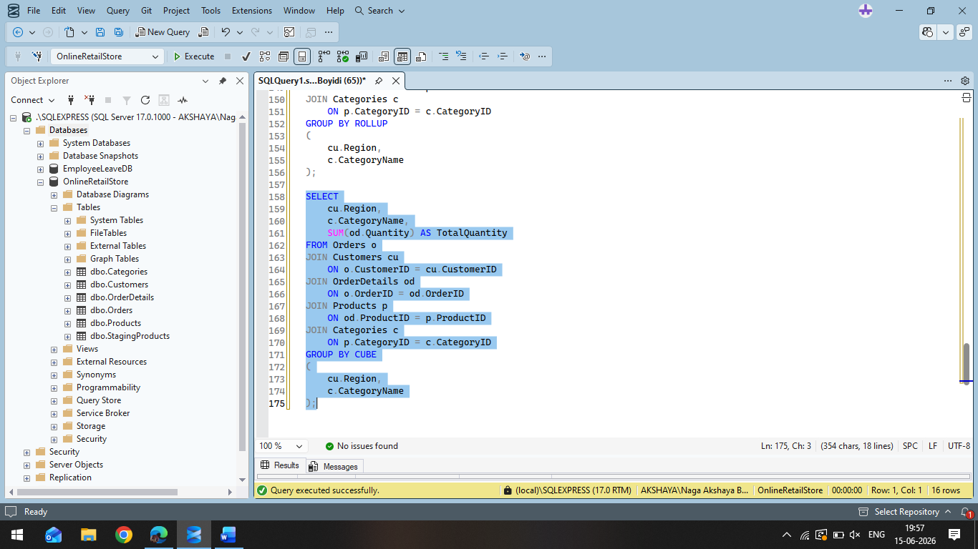

Output:
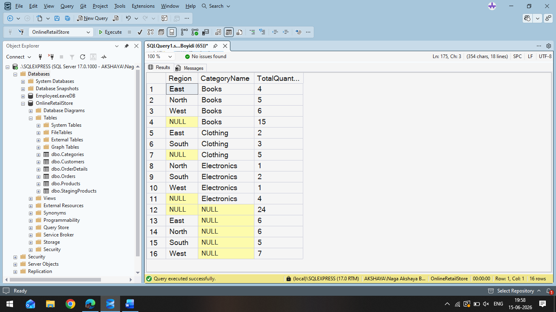

EXERCISE-03:
Query-01:
A recursive CTE repeatedly generates rows until a condition is met.
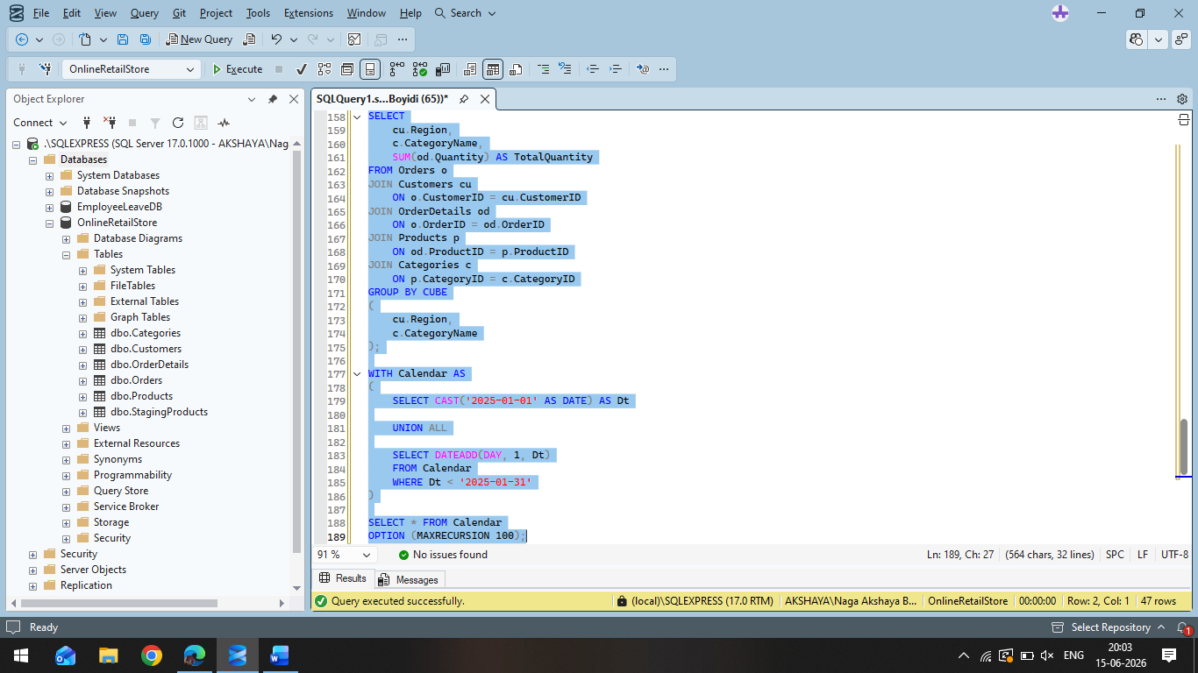

Output:

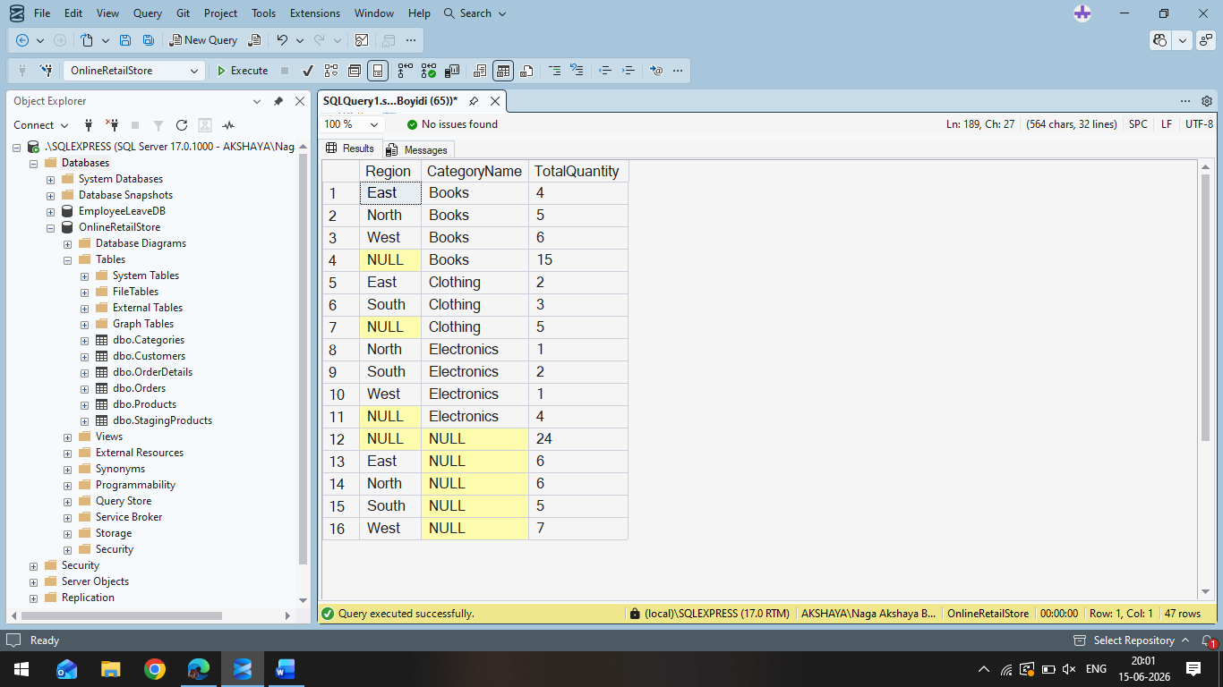

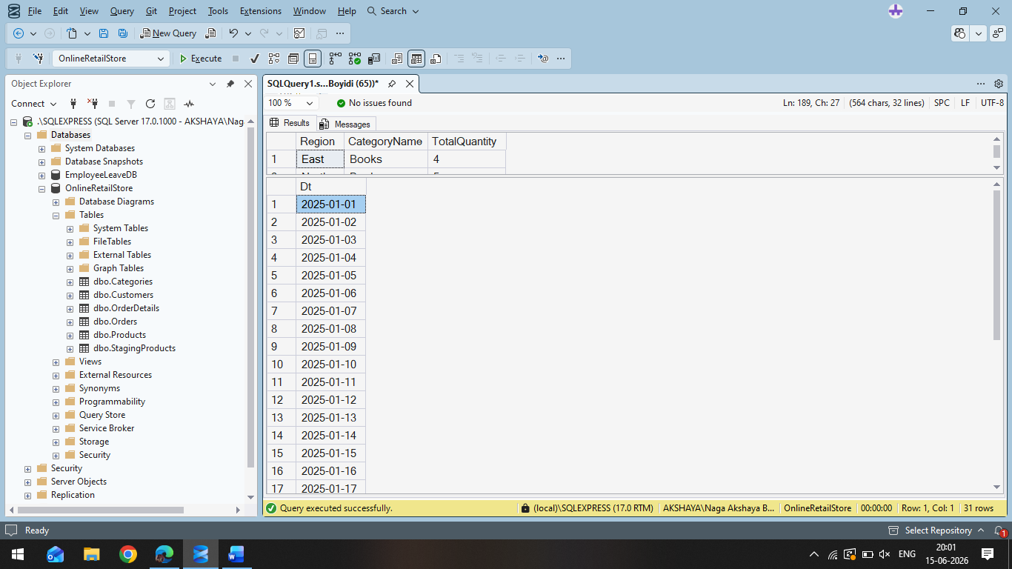

Query-02:
Step 1: Insert data into StagingProducts
Step 2: MERGE Query

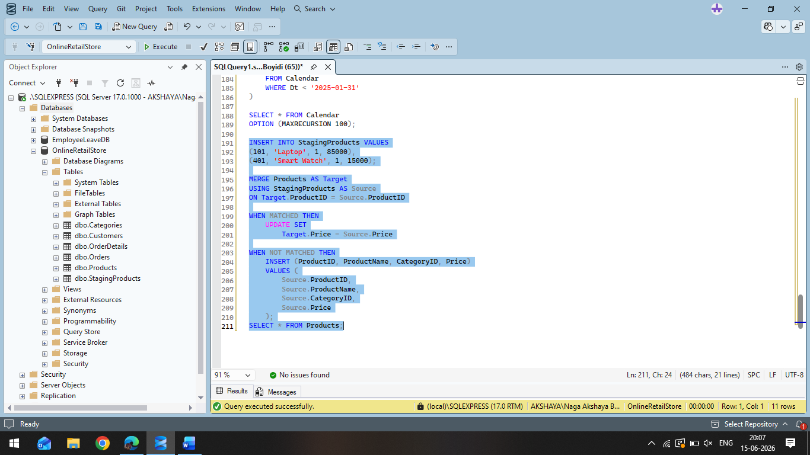

Output:

